ICIL 2016 INSTRUCTIONS FOR AUTHORS (14 PT BOLD WITH CAPITAL LETTERS TIMES NEW ROMAN, TWO LINES MAX.)

Katarzyna GDOWSKA¹, First Name SURNAME²
¹AGH Univerity of Science and Metallurgy, Faculty of Management
Mickiewicza 30, Krakow, Poland
²Institution
Address, City, Country

Abstract (12 pt, Times New Roman, bold)
The Abstract should not exceed 100 words, should state the principal objectives and the scope of the investigation, the methodology used, summarized results and principal conclusions. The text of the abstract should be in Times New Roman font style, Italic, 11 pt, justified.
Keywords (11 pt, Times New Roman, bold): instructions, paper, format, fonts (11 pt, Times New Roman, 3-5 words), 6 pt spacing before

1. PAPER FORMAT AND MARGINS
Please read these instructions carefully and prepare your paper according to them. Papers which are not prepared according to the instructions and the template will be returned to authors for corrections during reviewing process.
The paper needs to be written in the third person (impersonal style). The use of the International Metric System (SI) units is mandatory.
To be sure that your paper is prepared according to this template use this file with appropriated styles for preparation and save it with a new filename: surnameoffirstauthor.doc(x) (for example: gdowska.doc). In the case that you are not using this file for preparation of your paper please made all necessary adjustment according to requirements in next paragraphs.
Paper should be prepared on standard A4 (210×297 mm) format. The top margin should be set at 2.5 cm, the bottom, left and right margins at 2 cm, mirror margins; different first page; different odd and even pages with header and footer size of 1.2 cm. The completed paper including graphics and references should be 6 to 8 pages. The text of your paper should be written in Times New Roman font, 11 pt normal, justified, single spaced, 6 pt spacing before paragraphs, and 12 pt spacing before next heading title. The paper must be written in English, using Microsoft Word and submitted in electronic version using address https://easychair.org/conferences/?conf=icil2016. To be sure that your paper is prepared according to this template use this file with appropriated styles for preparation and save it with a new filename: surnameoffirstauthor.doc(x) (for example: gdowska.doc). In the case that you are not using this file for preparation of your paper please made all necessary adjustment according to requirements in next paragraphs.
Questions! Problems! Please contact us on the following address: icil@zarz.agh.edu.pl (we are ready and happy to help you!).
We are looking forward to meet you in Zakopane in September/October, 2016.

2. PAPER TITLE AND AUTHOR(S)
The title of your paper should be 14 pt, bold in all capital letters, Times New Roman font, starts at 3 cm from the paper top. One line space (12 pt) separates the title from the first author listing. Author’s name should consist of her/his first name, middle initial (if it is necessary) and last name. It should be 12 pt, Times New Roman bold. Institution, address, city and country should be written in 12 pt Times New Roman normal. Title of the paper, author(s) name and affiliation(s) must be centered under the margins.

3. TEXT HEADING
The primary text heading should be numbered by 1., 2., … and should be in 12 pt, bold, capital letters, left aligned. Avoid leaving a heading at the bottom of a page, with the subsequent text starting at the top of the next page. If necessary, use extra spacing to push heading on the next page.

3.1. Sub-heading
Sub-heading should be numbered by X.1., X.2., … and should be in 12 pt, bold, upper and lower case letters, left aligned.

4. FIGURES
All figures and tables should be saved with the document, positioned in their places and named accordingly to its position in the text.
Figures (photos, graphs) should be in high quality suitable for reproduction and print. Place them centered and as close as possible to the first reference to them in the paper with 6 pt spacing before. Apply figure style on all figures.
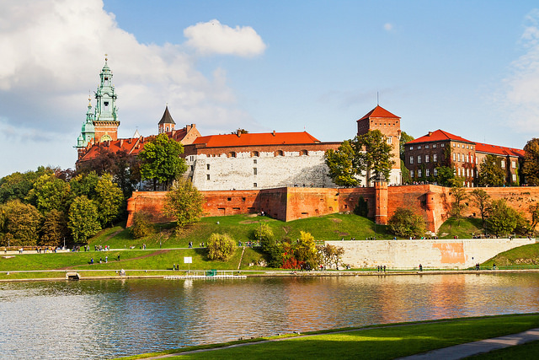
Figure 1 – Title of figure
Figures must be cited in consecutive numerical order in the text and referred to in both the text and in caption as Figure 1, Figure 2, etc. Caption should be below figure, centered with 6 pt spacing before.

5. TABLES
Tables must be cited in consecutive numerical order in the text and referred to in both the text and the caption as Table 1, Table 2, etc.
Table 1 – Title of table
Place them centered, with caption also centered below table. There should be 6 pt spaces between table caption and text, and between table caption and table. The examples of figure and table numbering and titling are given above.

6. EQUATIONS
Equations are 2 cm indent from left, left aligned and numbered consecutively, from 1 upwards, in rounded brackets. Leave 6 pt spaces before it.
(1)

7. PAGE NUMBERING
Do not put number on the pages.

8. REFERENCES
References should be listed at the end of the paper as they appear in the text. If a publication is referred in the text, use [1] for one reference, or [1,2,3] for more than one. Use the following styles for journals, proceedings and books, respectively (there is no spacing between lines, 0,8 cm hanging):
- Nowak, A.: Article title, Journal of ABCD, 1(2014)1, 1–5.
- Nowak A., Kowalski B.: Article in conference proceedings, Proceedings of Conference 2014, Krakow, February 2014, 11–13.
- Nowak, A., et al.: Krakow – history of the city, Publisher, City, 2015.
- Nowak, A.: Article, www.icil2016.org, dd-mm-yyyy.

